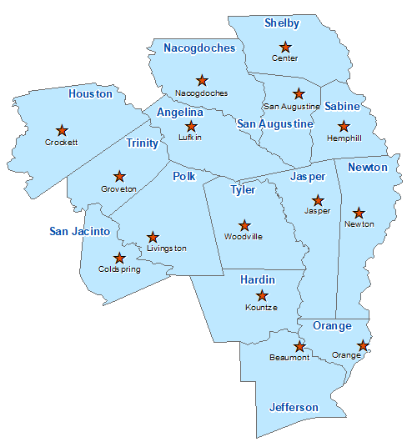Hardin County Summary 2021

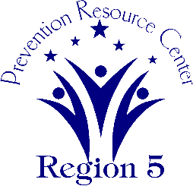The Prevention Resource Center (PRC) provides data for all 15 counties in Region 5. This is a summary of a portion of the data reported in the 2021 Regional Needs Assessment for Hardin County. The RNA focuses on underage drinking and tobacco use and on the abuse of prescription medication as well as other illicit drugs.

Population Race/Ethnicity

56,626 White Hispanic Black Asian Other

48,938 3,303 3,045 316 1,024

(86.4%) (5.8%) (5.4%) (0.6%) (1.8%)

Population Growth Language

3.6% English – 94.7% Other Than English – 5.3%

Median Household Income Unemployment Rate

$60,339 9.0

Crime Rate Single-Parent Households

11.3 per 1K 1,333 (6.5%)

Life Expectancy Suicide Rate

75.9 years 21.4 per 100K

OSAR Screenings

36.6 per 10K