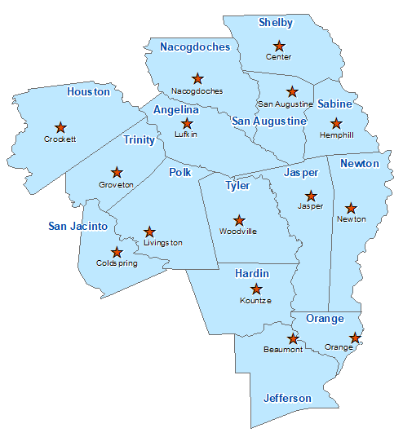Newton County Summary 2021

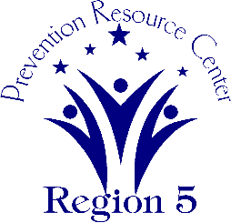The Prevention Resource Center (PRC) provides data for all 15 counties in Region 5. This is a summary of a portion of the data reported in the 2021 Regional Needs Assessment for Newton County. The RNA focuses on underage drinking and tobacco use and on the abuse of prescription medication as well as other illicit drugs.

Population Race/Ethnicity

13,654 White Hispanic Black Asian Other

9,729 689 2,828 76 332

(71.3%) (5.0%) (20.7%) (0.6%) (2.4%)

Population Growth Language

-5.5% English – 97.4% Other Than English – 2.6%

Median Household Income Unemployment Rate

$40,101 11.0

Crime Rate Single-Parent Households

9.0 per 1K 575 (10.8%)

Life Expectancy Suicide Rate

76.9 years 17.6 per 100K

OSAR Screenings Youth Served by Prevention

18.1 per 10K 5,951