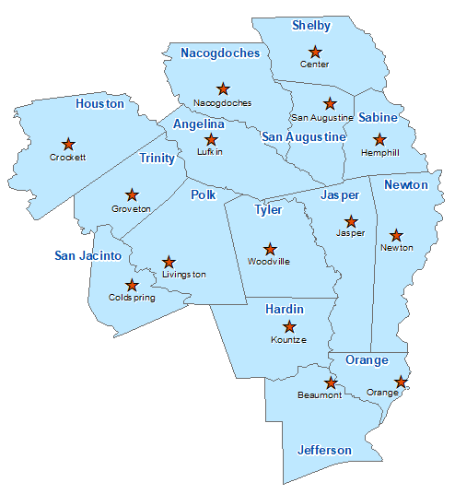Polk County Summary 2021

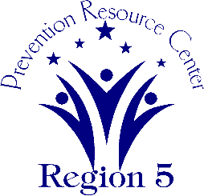The Prevention Resource Center (PRC) provides data for all 15 counties in Region 5. This is a summary of a portion of the data reported in the 2021 Regional Needs Assessment for Polk County. The RNA focuses on underage drinking and tobacco use and on the abuse of prescription medication as well as other illicit drugs.

Population Race/Ethnicity

49,480 White Hispanic Black Asian Other

34,629 7,993 5,078 241 1,539

(70.0%) (16.2%) (10.3%) (0.5%) (3.1%)

Population Growth Language

9.0% English – 85.8% Other Than English – 14.2%

Median Household Income Unemployment Rate

$49,279 8.7

Crime Rate Single-Parent Households

19.5 per 1K 1,393 (7.7%)

Life Expectancy Suicide Rate

73.7 years 27.3 per 100K

OSAR Screenings Youth Served by Prevention

42.5 per 10K 13,700