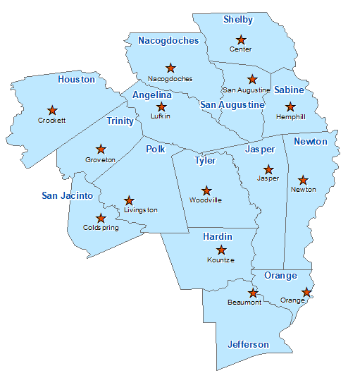Tyler County Summary 2021

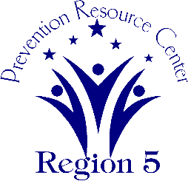The Prevention Resource Center (PRC) provides data for all 15 counties in Region 5. This is a summary of a portion of the data reported in the 2021 Regional Needs Assessment for Tyler County. The RNA focuses on underage drinking and tobacco use and on the abuse of prescription medication as well as other illicit drugs.

Population Race/Ethnicity

21,313 White Hispanic Black Asian Other

16,448 1,874 2,465 60 466

(77.1%) (8.8%) (11.6%) (0.3%) (2.2%)

Population Growth Language

-2.1% English – 90.4% Other Than English – 9.6%

Median Household Income Unemployment Rate

$44,497 9.9

Crime Rate Single-Parent Households

10.4 per 1K 363 (5.1%)

Life Expectancy Suicide Rate

75.7 years 20.1 per 100K

OSAR Screenings Youth Served by Prevention

25.7 per 10K 5,823