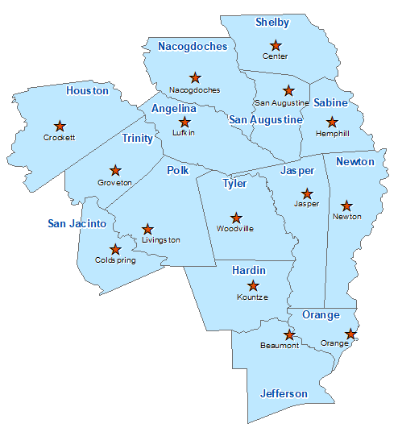Jasper County Summary 2021

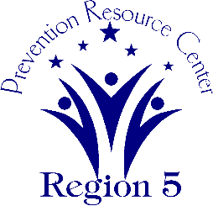The Prevention Resource Center (PRC) provides data for all 15 counties in Region 5. This is a summary of a portion of the data reported in the 2021 Regional Needs Assessment for Jasper County. The RNA focuses on underage drinking and tobacco use and on the abuse of prescription medication as well as other illicit drugs.

Population Race/Ethnicity

35,456 White Hispanic Black Asian Other

25,797 3,026 5,561 230 842

(72.8%) (4.6%) (15.7%) (0.6%) (2.4%)

Population Growth Language

-0.7% English – 93.4% Other Than English – 6.6%

Median Household Income Unemployment Rate

$44,370 11.2

Crime Rate Single-Parent Households

21.1 per 1K 952 (7.4%)

Life Expectancy Suicide Rate

74.9 years 24.9 per 100K

OSAR Screenings Youth Served by Prevention

37.6 per 10K 18,502