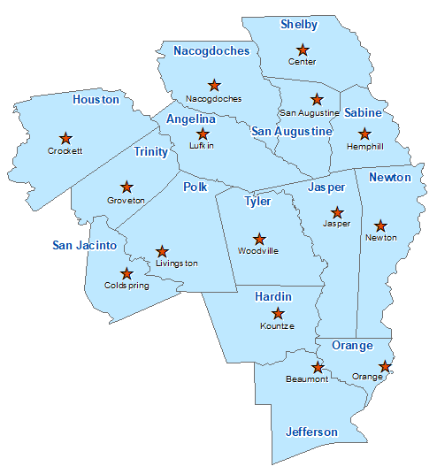Trinity County Summary 2021

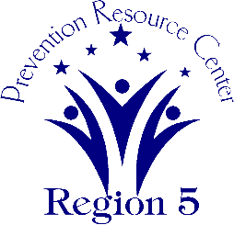The Prevention Resource Center (PRC) provides data for all 15 counties in Region 5. This is a summary of a portion of the data reported in the 2021 Regional Needs Assessment for Trinity County. The RNA focuses on underage drinking and tobacco use and on the abuse of prescription medication as well as other illicit drugs.

Population Race/Ethnicity

14,183 White Hispanic Black Asian Other

10,970 1,487 1,378 51 297

(77.3%) (10.5%) (9.7%) (0.4%) (2.1%)

Population Growth Language

-2.8% English – 91.8% Other Than English – 8.2%

Median Household Income Unemployment Rate

$41,357 8.1

Crime Rate Single-Parent Households

5.2 per 1K 306 (5.1%)

Life Expectancy Suicide Rate

74.0 years 17.5 per 100K

OSAR Screenings Youth Served by Prevention

14.0 per 10K 5,520