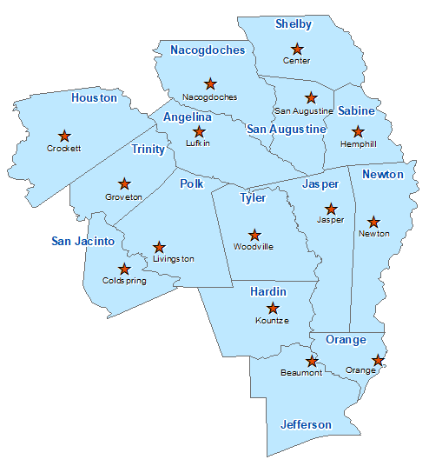Jefferson County Summary 2021

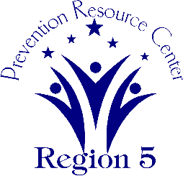The Prevention Resource Center (PRC) provides data for all 15 counties in Region 5. This is a summary of a portion of the data reported in the 2021 Regional Needs Assessment for Jefferson County. The RNA focuses on underage drinking and tobacco use and on the abuse of prescription medication as well as other illicit drugs.

Population Race/Ethnicity

259,249 White Hispanic Black Asian Other

102,182 55,353 85,136 11,324 5,254

(39.4%) (21.4%) (32.8%) (4.4%) (2.0%)

Population Growth Language

2.8% English – 77.4% Other Than English – 22.6%

Median Household Income Unemployment Rate

$51,248 11.9

Crime Rate Single-Parent Households

32.1 per 1K 8,679 (9.3%)

Life Expectancy Suicide Rate

76.2 years 12.4 per 100K

OSAR Screenings

36.7 per 10K