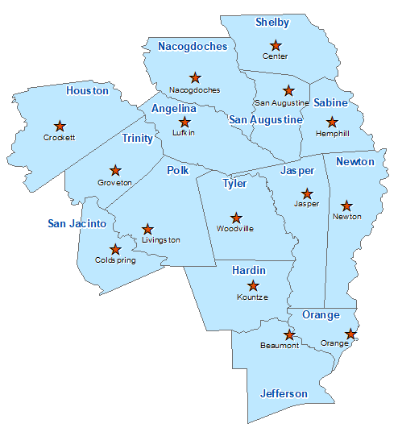Angelina County Summary 2021

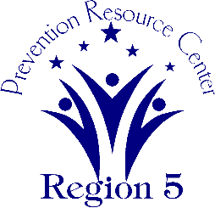The Prevention Resource Center (PRC) provides data for all 15 counties in Region 5. This is a summary of a portion of the data reported in the 2021 Regional Needs Assessment for Angelina County. The RNA focuses on underage drinking and tobacco use and on the abuse of prescription medication as well as other illicit drugs.

Population Race/Ethnicity

90,739 White Hispanic Black Asian Other

53,205 21,325 13,706 885 1,618

(58.6%) (23.5%) (15.1%) (0.9%) (1.8%)

Population Growth Language

4.6% English – 81.5% Other Than English – 18.5%

Median Household Income Unemployment Rate

$50,453 7.6

Crime Rate Single-Parent Households

35.3 per 1K 2,931 (9.4%)

Life Expectancy Suicide Rate

76.3 years 15.1 per 100K

OSAR Screenings Youth Served by Prevention

55.0 per 10K 53,906