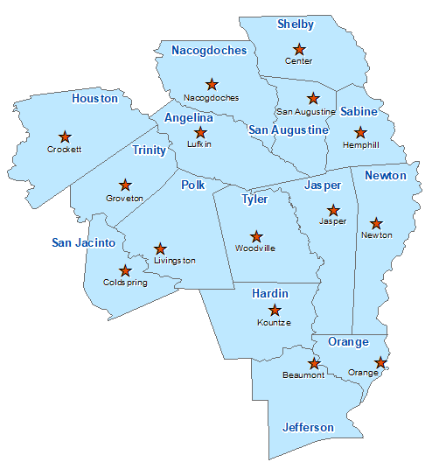Nacogdoches County Summary 2021

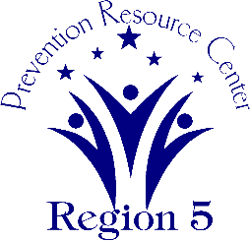The Prevention Resource Center (PRC) provides data for all 15 counties in Region 5. This is a summary of a portion of the data reported in the 2021 Regional Needs Assessment for Nacogdoches County. The RNA focuses on underage drinking and tobacco use and on the abuse of prescription medication as well as other illicit drugs.

Population Race/Ethnicity

64,181 White Hispanic Black Asian Other

38,342 13,177 10,204 1,050 1,408

(59.7%) (20.5%) (15.9%) (1.6%) (2.2%)

Population Growth Language

-0.5% English – 83.0% Other Than English – 17.0%

Median Household Income Unemployment Rate

$44,847 6.6

Crime Rate Single-Parent Households

22.8 per 1K 1,806 (7.6%)

Life Expectancy Suicide Rate

77.0 years 19.5 per 100K

OSAR Screenings Youth Served by Prevention

35.6 per 10K 16,397